FAMIS



Table of Contents

Getting Started in FAMIS…………………………………………..……………….…Page 2

Submitting a Request……………………………...…………………….…………….Page 3-5

Checking Your Email…………………………………………………...…………..….Page 6

Call B&G If……………………………………………………………………...….……Page 6

Did You Know?…………………….…………………………..………………….……Page 6-7

Look Up Requests……………………………………..….………………………..….Page 7-16

When You Know Request ID Number………………...……………………………Page 7

Search All Requests For the Last Week………………….………………………..Page 8-9

Search by Date…………………………………………..……………………………Page 10

Filtering Searches………………………………………………………………….…Page 11-13

Filter By Type…………………………………..………………….…….……..Page 11

Filter By Notes (Search Text)………………………….………………..……Page 12-13

Tips for Searching In FAMIS……………………………………...……….…….….Page 13-14

Getting over 1,000 Results………………………………………....….……..Page 13

Sorting Your Results……………………………………….……..…….……..Page 14

Don’t Lose Your Search………………………………….……..……….……Page 14

FAMIS Tabs In Your Browser………………………….…….……..………..Page 15

Trouble Finding A Request……………………………..….….….……..…...Page 15

Other Ways To Look Up Requests…………………………………….…………….Page 16

**Getting Started**

Step 1 - To bring up FAMIS on the internet…

**Press “Ctrl” key and click on this link at the same time**

<https://ccs.famis.com/360loginscreen.asp>

Step 2 – Get logged in!

           If you don’t know your user name or password, please contact B&G

Step 3 – Bookmark and name the page so you can easily find it later

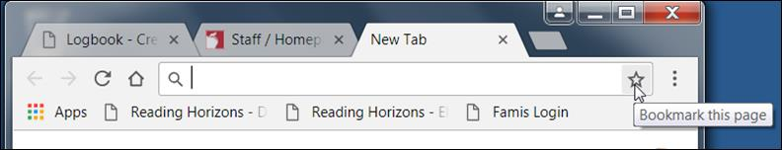

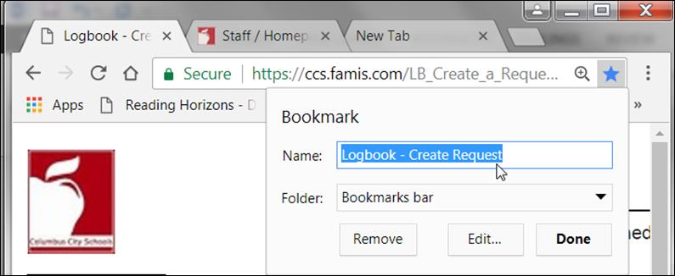

 You can name it whatever you want, just make sure it’s something you’ll remember, then click **Done**

After that, you can find FAMIS somewhere in this area…  
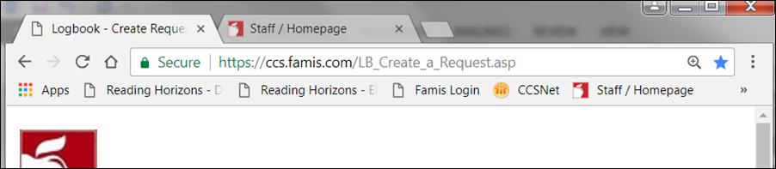

**Submitting a Request**

Step 1 – Submit a request in FAMIS

Step 2 - Check your email to see if any follow up is needed from you

Step 3 - Look at your past requests for updates (you should do this before you call for an update or submit another request)

 More details for each step can be found below.

Step 1 – Submit a Request in FAMIS

Sections to fill out:

The main things you need to fill out are **Type, Sub Type, Priority, and Describe your Request.** Each one is covered a little bit below, if you have any questions you can give Buildings and Grounds a call and we’ll be happy to help you.

**Type and Sub Type**:

The main Types you will use are **Carpentry**, **HVAC**, **Electrical**, **Locksmith**, **Plumbing**, **Paint (Prev Maint Shop) and Landscaping**.  When you have time, you can click on each Type to see what is covered in its Sub Types, this will give you an idea of who does what. Each “Type” has some kind of generic Sub Type option, it’s not possible to list every kind of request in FAMIS.

 Please don’t leave Type and Sub Type as the default (Administration and New Work)

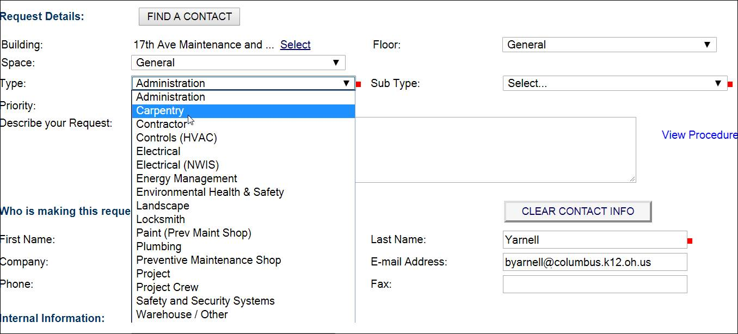

Below are the **Sub Types** for Carpentry as an example.  Pick the best Sub Type for your needs, or just pick the generic option.

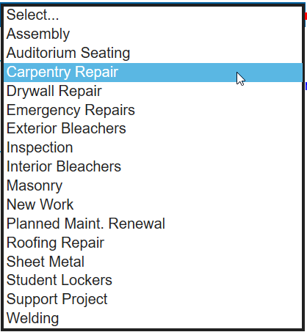

**Priority**:

**Most requests will be Priority 3**.  Priority 2 would be for issues that will cause building damage or greatly disrupt the learning environment.  Priority 1 should be reserved for the most drastic issues, burning smells, AC out in the entire building or security issues like an external door that won’t shut.  **Priority 1 issues should be called in, not entered into FAMIS**.

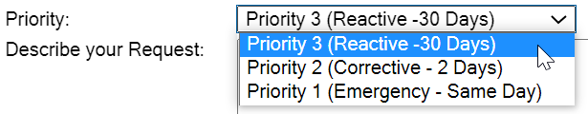

**Describe Your Request**:

When you are describing your request, please give us as much information as you can, what the problem is, what room it’s in, how many (if that applies), etc.

Not enough information…

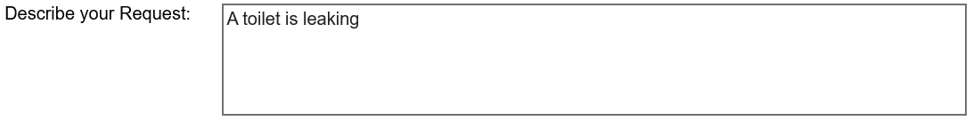

Lots of information… 

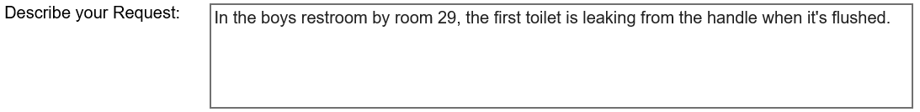

Step 2 – Check Your Email

Every time your request is updated, you will get an email, it’s important to check those emails for messages to you, sometimes we need more information.

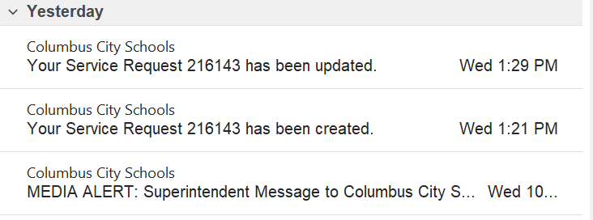

Please call B&G if you:

Have any questions about any step in the process

Aren’t getting emails from FAMIS

Can’t see “My Requests”

Don’t know your logon and password

Did You Know?

* Fleet Services fixes lawn equipment and floor equipment.
* TV and Smart Board mounting are Electronic Repairs performed by Electrical, not Carpentry.
* For pest control, we would like to know how many “pests” you’ve seen. Even if you have to guess (like for ants), it’s still helpful information.
* The B&G warehouse is just a small warehouse at 17th Ave, it is not the large Warehouse on Hudson and we can’t process their requests, you have to contact them.
* For Landscaping requests, you should change your building in FAMIS to “Grounds”.

1. 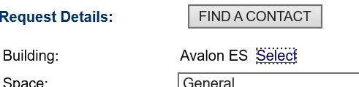 2. 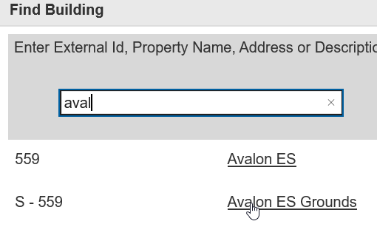

Step 3 – Look Up Requests

**If you know the request ID, you can just type it in and click find…**

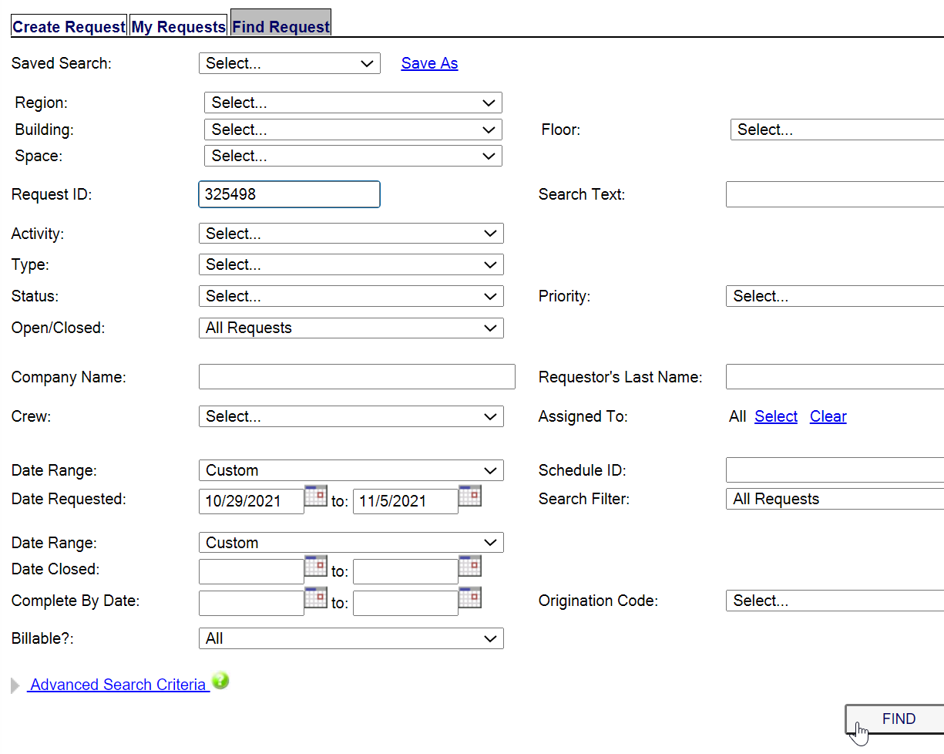

**To pull up all requests for the past week…**

On the **Find Request** tab in FAMIS, if you don’t change anything, and just click the Find button, it will give you a list of all the requests for your building, for the past week.

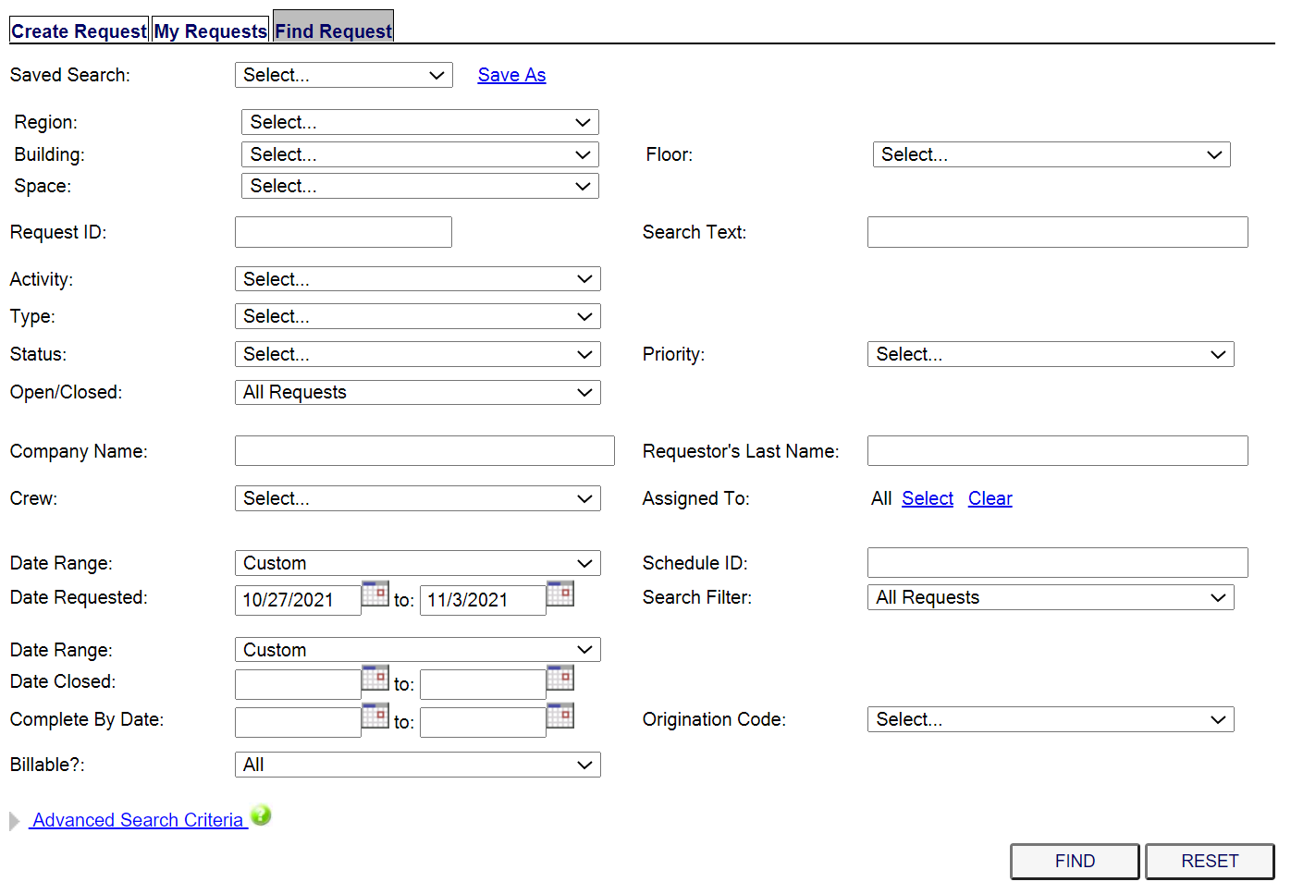

The search results look like this…

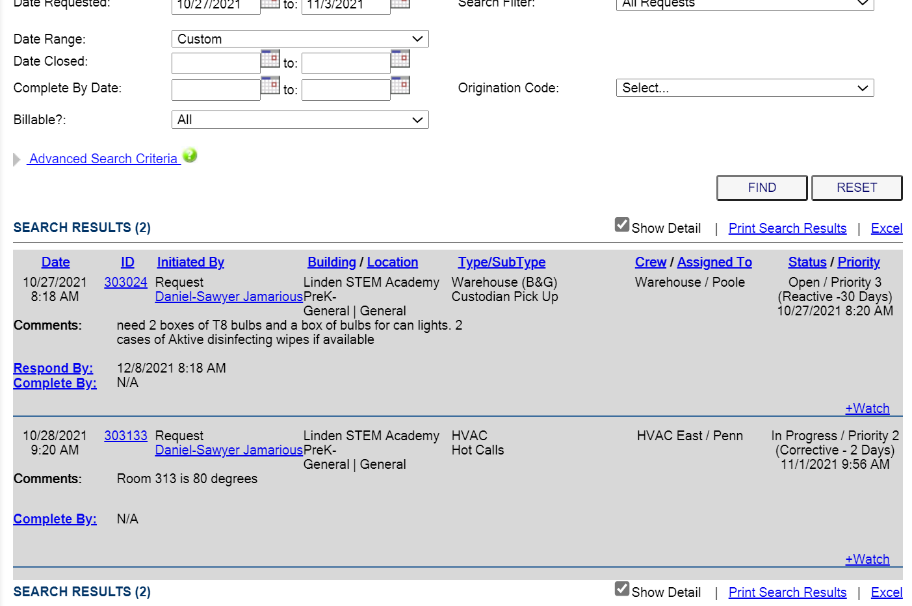

**To Search For Requests by Date…**

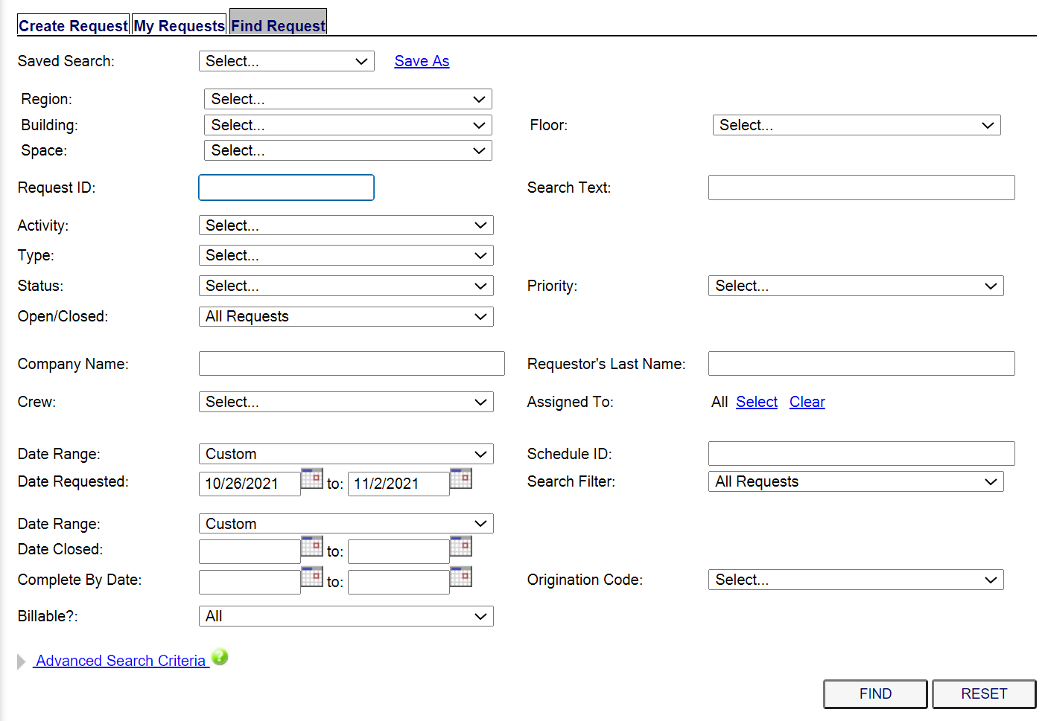



You can change the date range by clicking on the little calendars. The dates will always start out being for a week ago, through today.

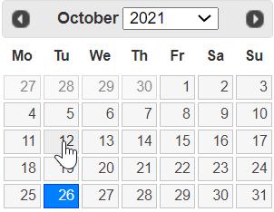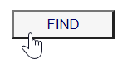

Then click Find

Click on the date(s) that you want,

**Filtering your searches**

You can have a longer date range and filter your results in other ways…

Option 1: Filter results by “Type”

Example: If you know the request you are looking for was a Carpentry request, you can choose to only look at Carpentry requests…

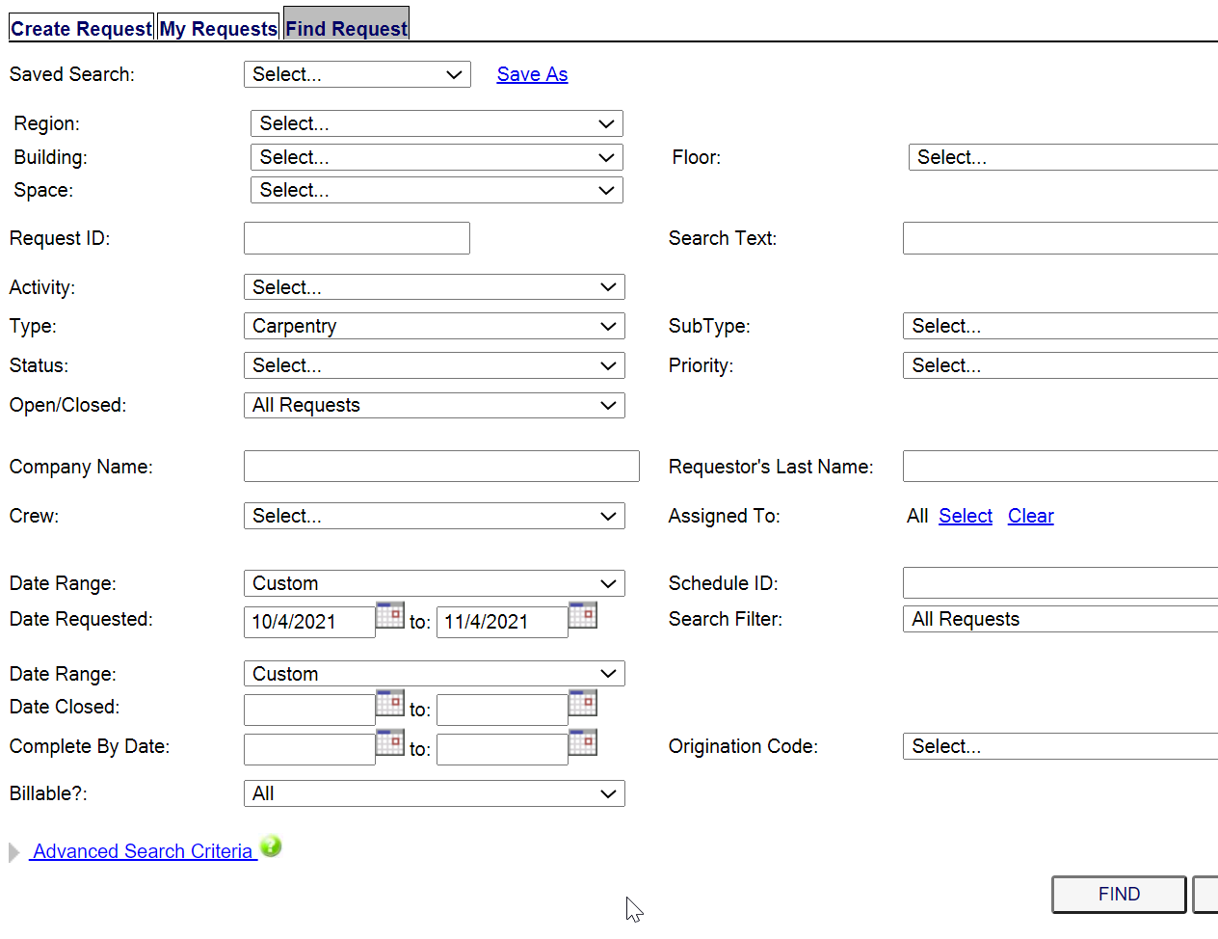

This search will return requests with the “Type” of Carpentry, that were requested during your chosen date range.

Option 2: Filter results by the notes in the request

Example: You want to find a request that was for something in room 213. In the “Search Text” box, you can enter words and numbers…

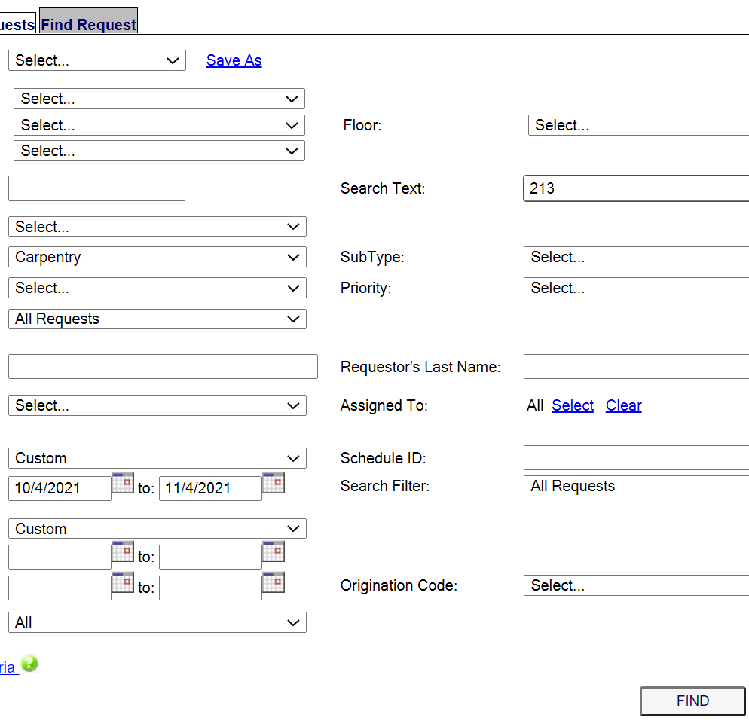

This search will return requests for Carpentry, with “213” in the text, requested during your chosen date range.

When using **Search Text**…

* You can use any word you want, but try to keep it simple… use words like **sink**, **kitchen**, **oven**, **leak**, etc.
* It may be a different word than you are thinking
* Example: you are looking for the word **Stair**, but it’s in the notes as **Step**.
* Try not to use plurals
* Example: If you search for the word **Stair**, you will get results with the word **Stair** and with the word **Stairs**. But, if you search for the word **Stairs**, you won’t get the word **Stair** in your results.
* Searching for room numbers
* Example: The room number is **N102**, in a request, this could be entered with or without a space, you may need to search it both ways, **N102** and

**N 102**.

**As a rule, in FAMIS, everyone should type room numbers with no spaces, this will make searching for requests easier for everyone**

Option 3: Mix and match filters

You can use any combination of filters you want, or none. The more you narrow your search, the less results you will get back. Some ways of filtering are more effective than others, but the more you practice, the faster you will find the requests that you are looking for. The most common filters used are the ones shown in this document.

Tip #1: If your search has more than 1,000 results, FAMIS won’t display them

If your search has 1,000 or more results, FAMIS won’t display them and you will have to use a filter (or filters) to reduce the results…

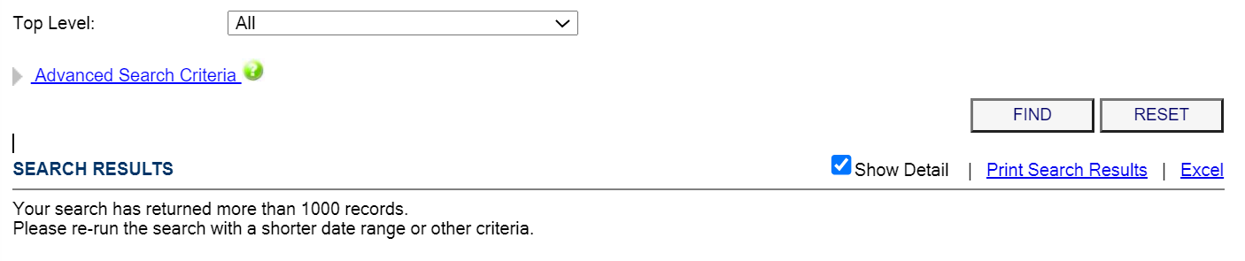

Tip #2: Sorting through your results

You can click on each header and it will rearrange the list by that category…

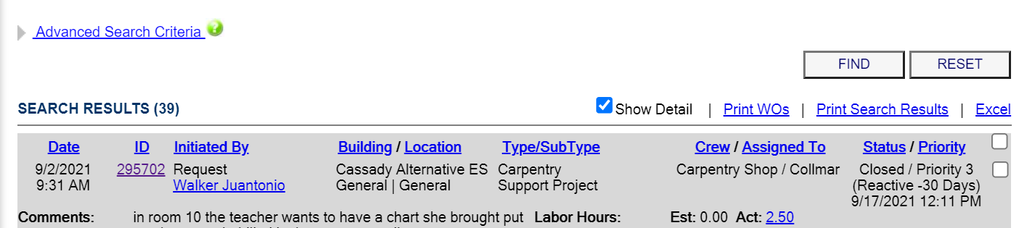

If you click on **Date**, it will put the newest requests on top, instead of the oldest. If you click on **ID**, it will put the requests in order by Request ID, the other headers will arrange the list alphabetically.

Tip #3: Open a request without losing your search…

When you find the request that you want to open, if you just click on the request ID, you will lose your search. To keep the search, **RIGHT CLICK** on the request ID, then click on **Open link in new tab**

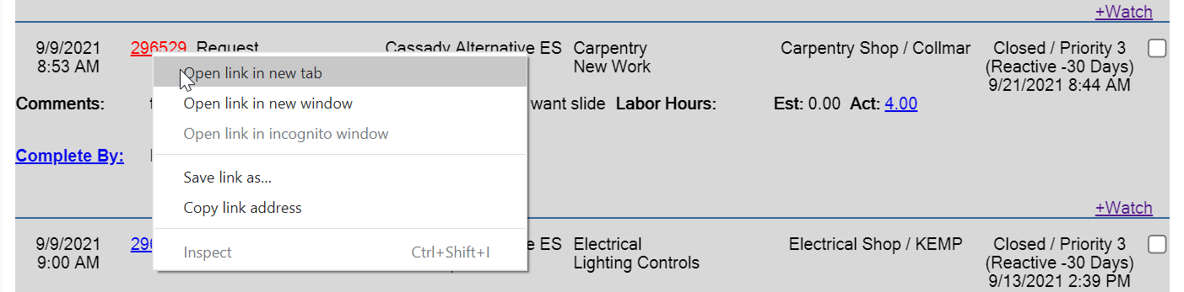

This will open a new tab in your browser, one tab will contain your search, and one will contain the request you just opened, click on the **Request Details** tab to see the request you want to look at.

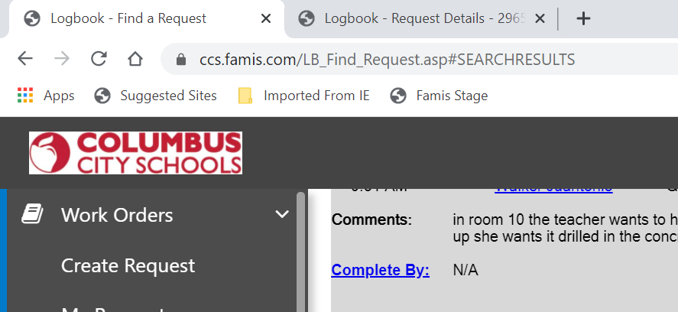

Tip #4: Be careful not to get too many tabs open…



You should close tabs as you go, by clicking the **X** when you are done with a request…



Tip #5: The request may not be where you expect it

* The Type and Sub Type may be wrong, or they may have gotten changed if the request was sent to a different department.
* Example: The request started with the Type of **Administration** and never got corrected to **Carpentry**, or **Plumbing**, etc.
* Example: The request started as a **Paint** request, but was changed to **Carpentry** later when it was discovered the area needed repaired before it could be painted.
* The request may have been entered long before you think it was. It’s hard to remember exactly when we put in every request, you may have to use a long date range to find a request.

Tip #7: Other ways to look up requests

My Requests

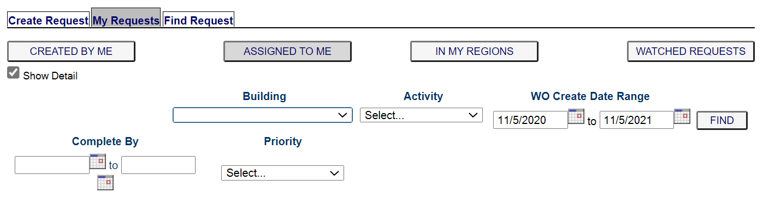

If you click on the My Requests tab in FAMIS, you have other tabs to choose from. The only two you will need are **CREATED BY ME** and **IN MY REGIONS**…

* **Created By Me** – Shows you all the requests that YOU created in the date range. The open requests are at the top, the closed requests are at the bottom.
* **In My Regions** – Shows you all the ***open*** requests for your building in the date range. This search doesn’t show closed requests.

Both of these are limited searches but can be a quick way to bring up requests if you know your request meets the criteria of the search.